StatefulSet

A StatefulSet in Kubernetes is a workload controller used to manage stateful applications that require stable pod identities, persistent storage, and ordered deployment/scaling.
It ensures that each pod:
- has a unique and stable name
- keeps the same persistent storage even after restarts
- is created, updated, and deleted in a specific order
StatefulSet = Deployment + Stable Identity + Persistent Storage + Ordered Startup

Pre-requisites
- Kubernetes cluster ready (minikube, kind, EKS, etc.)
- kubectl installed and configured
- Basic understanding of Pods, Services, and PVCs

Step 1 – Create a Headless Service
A headless service is needed for pod-to-pod communication with stable DNS records.
# headless-svc.yaml
apiVersion: v1
kind: Service
metadata:
name: nginx
spec:
clusterIP: None # headless
selector:
app: nginx
ports:
- port: 80
name: web
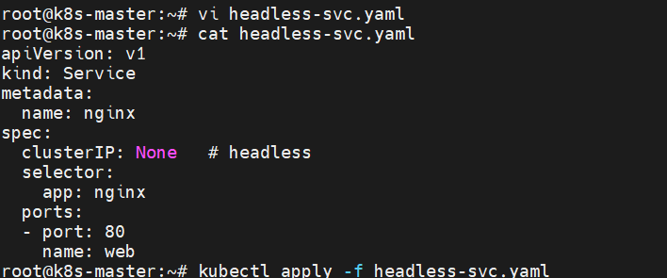
Command:
kubectl apply -f headless-svc.yaml
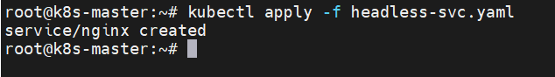
Check:
kubectl get svc nginx
You should see CLUSTER-IP as <none>.
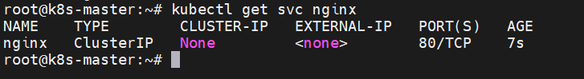

Step 2 – Create the StatefulSet
# statefulset-nginx.yaml
apiVersion: apps/v1
kind: StatefulSet
metadata:
name: web
spec:
serviceName: "nginx" # must match the headless service name
replicas: 3
selector:
matchLabels:
app: nginx
template:
metadata:
labels:
app: nginx
spec:
containers:
- name: nginx
image: nginx:1.23
ports:
- containerPort: 80
volumeMounts:
- name: www
mountPath: /usr/share/nginx/html
volumeClaimTemplates:
- metadata:
name: www
spec:
accessModes: [ "ReadWriteOnce" ]
resources:
requests:
storage: 1Gi

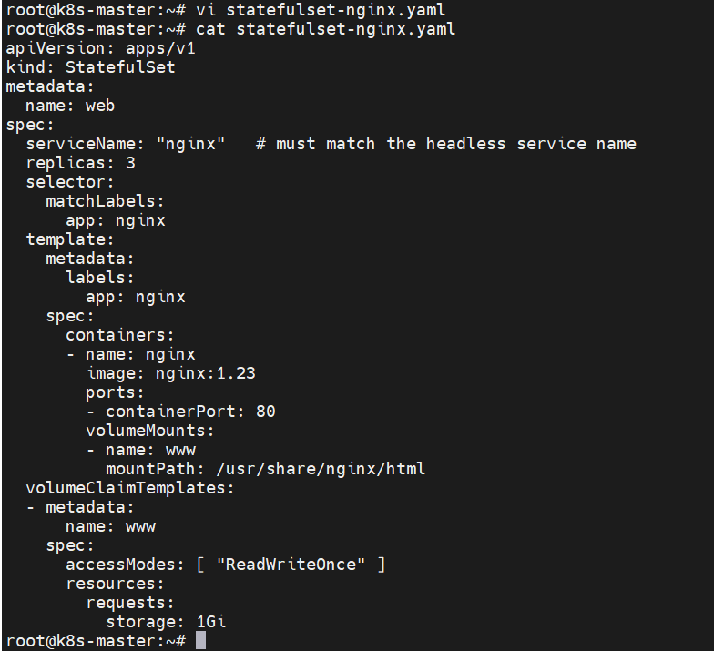
Command:
kubectl apply -f statefulset-nginx.yaml
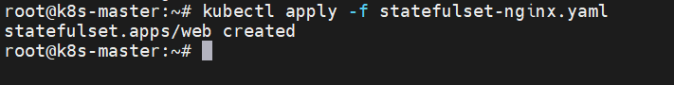
Check:
kubectl get statefulsets
kubectl get pods -l app=nginx
Notice pod names: web-0, web-1, web-2 (created one by one).
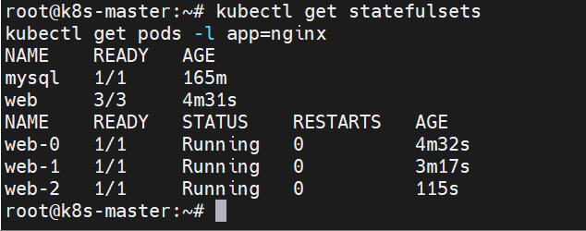

Step 3 – Observe the stable network identities
kubectl exec -it web-0 -- hostname
kubectl exec -it web-1 -- hostname
kubectl exec -it web-2 -- hostname
Output will match pod names (web-0, web-1, web-2).
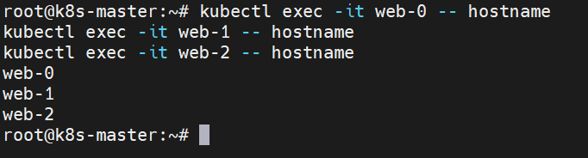
Check DNS resolution:
kubectl run -it tmp --image=busybox --restart=Never -- sh
nslookup web-0.nginx
nslookup web-1.nginx
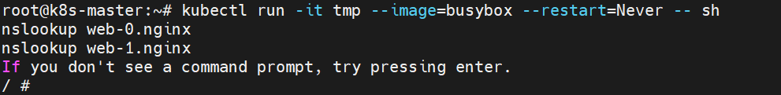

Step 4 – Test persistent storage
Edit content inside web-0:
kubectl exec -it web-0 -- sh -c "echo 'Hello from web-0' > /usr/share/nginx/html/index.html"
Delete web-0:
kubectl delete pod web-0
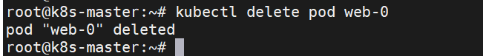
Check that it comes back with the same data:
kubectl exec -it web-0 -- cat /usr/share/nginx/html/index.html
The file should still contain “Hello from web-0” — proving persistence.
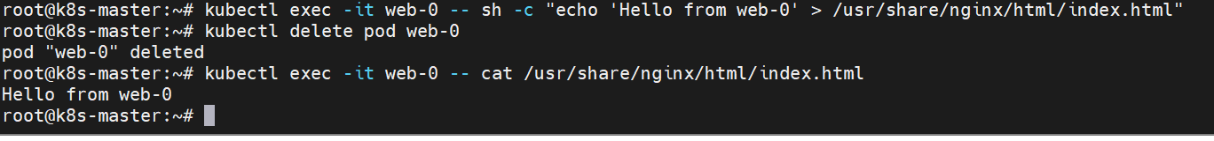

Step 5 – Scale up and scale down
Scale to 5 pods:
kubectl scale statefulset web --replicas=5
kubectl get pods -l app=nginx
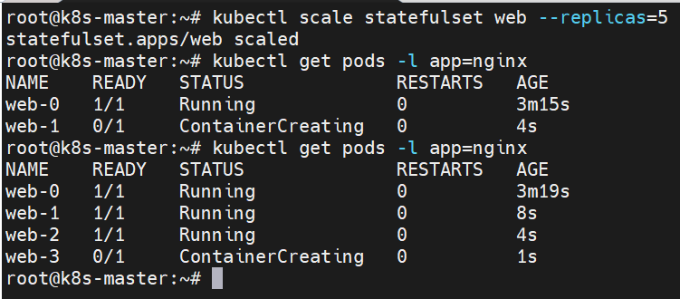
Scale down to 2 pods:
kubectl scale statefulset web --replicas=2
kubectl get pods -l app=nginx
PVCs for deleted pods still exist — data is preserved if scaled up again.
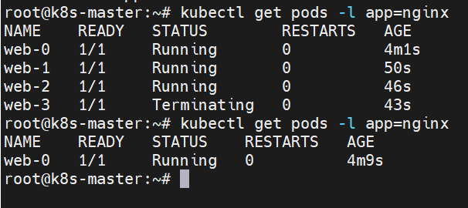

Step 6 – View PVC and PV mapping

If a pod is deleted but its PVC and PV still exist, the storage (data) remains intact, and the new pod will reattach to the same PersistentVolumeClaim and get the same data back.
kubectl get pvc
kubectl get pv
You’ll see www-web-0, www-web-1, etc. mapped to PVs.
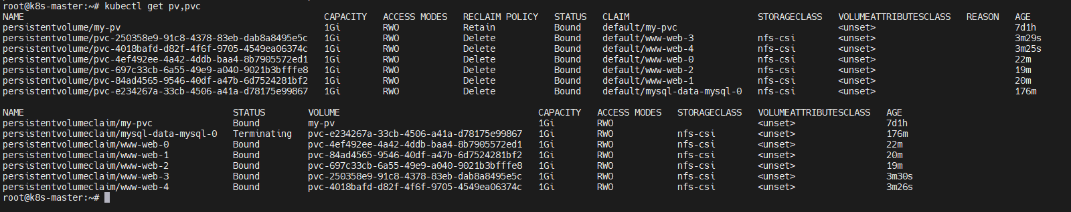

Step 7 – Cleanup
kubectl delete statefulset web
kubectl delete svc nginx
kubectl delete pvc --all
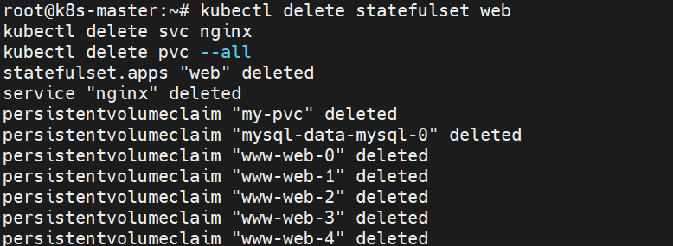

What students will learn from this demo
- Difference between Deployment and StatefulSet
- Importance of headless service
- How pod identity works (podname-ordinal.service-name)
- How persistent storage is retained across restarts
- Ordered pod creation and termination
- PVC → PV mapping for StatefulSets

